2026 Computer Graphics Project 2 Report
Name:
Student ID:

A. Video Link:

B. Scene Viewer
A. How the user controls the camera (e.g., mouse, keyboard, or both)

B. How the camera changes in response to each user input
Example:
– Input: drag mouse
– Behavior: camera rotates around the target point

C. Mesh Processing Design
A. Explain how you process face data (triangles, quads, a mix of triangles and
quads) and why you chose that approach

B. Explain how you organize data for rendering (e.g., vertex duplication, indexing,
etc.) and why you chose that approach

D. Hierarchical Modeling & Animation Design
A. Illustrate the hierarchical structure of your model
Example:
- level-4 structure:
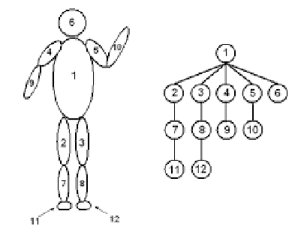

B. Explain how transformations are applied and how animation is defined

C. Explain why you designed the hierarchy and animation in that way

E. Lighting Design
A. Explain your choice of lighting parameters

B. How they affect the visual appearance and readability of your scene.

C. Explain why your choices improve the visibility and understanding of the scene

F. Others (Optional)

